

Plant Battle

A game by: Charles Henderson, Chris Kester, Shannon Zagst, and Simon Kingaby

Rules

To play. Each player starts with a seed. The goal is to gather 10 roots and 10 leafs to earn a flower. The first player to earn a flower wins.

# Setup

Separate the Seeds. Each player selects a seed.

Shuffle and place the Flowers face down in a pile in the center of the table.

Shuffle the rest of the cards and place in a stack in the center of the table.

# Dealing the Cards

Deal 7 cards to each player. Play starts to the left of the dealer and proceeds clockwise.

# Taking Your Turn

On your turn, you fill your hand to 8 cards. Then you can play a card or discard to get down to 7 or less cards in your hand. In order to nourish your seed you need each of the three resources: Sun, Soil, and Water. Once you have the three resources, you can play a leaf or root card.

On your turn, you can choose to play a counter card on your opponent’s resources. Clouds block the Sun, Drought blocks the Water, and Bugs block the Soil. Your opponent will then have to find the resource again to remove your counter card.

On your turn, you can choose to play an attack card that removes your opponent’s leafs or roots. Note: If you play an attack card that removes more than 1 leaf or root then your opponent can choose how to remove them. Unfortunately, if you play a remove 2 leafs and they only have a triple leafs in their leaf pile, they will have to discard the entire triple leafs card.

On your turn, you can choose to play a trump card. Grow lights trump clouds, and prevent the playing of clouds against you. Irrigation trumps drought and prevents the playing of drought against you. Pesticide trumps bugs and prevents the playing of bugs against you.

On your turn, you can choose to play a blessing card that allows you to grow roots and leafs faster. Each blessing card allows you to grow two roots or leafs cards in one turn.

Lastly, on your turn you can play a Stunted Growth card on your opponent. While this card is showing, they can only play leaf or root cards with a value of 1 leaf or 1 root. They cannot play 2's or 3's. This condition can be relieved by playing a Growth Spurt on top of the Stunted Growth card. When you play a Growth Spurt card, you can also play a leaf or root card (of any value).

# The Playmat

Each player receives a playmat for placing their cards.

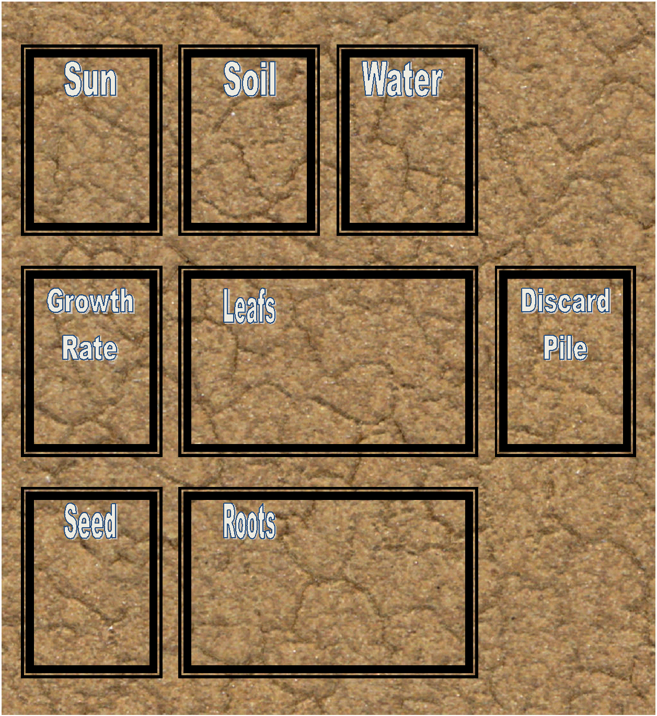

# The Cards

## Seeds

There are four seed cards. Each player selects a seed to start the game with.

|  |
| --- |
|  |

## Resource Cards

You need one of each resource showing to be able to grow roots and leafs.

|  |  |  |
| --- | --- | --- |
|  |  |  |

## Counter Cards

Play a counter card on top of one of the three resources to block it. You cannot grow a root or leaf while any of your resources are blocked. Play the resource card on top of the blocker to continue growing roots and leafs.

|  |  |  |
| --- | --- | --- |
|  |  |  |

## Trump Cards

There are three trump cards in the deck. Each one played on top of a specific resource and blocks the counter cards for the rest of the game. Grow lights trump clouds and prevent the playing of clouds against you. Irrigation trumps drought and prevents the playing of drought against you. Pesticide trumps bugs and prevents the playing of bugs against you.

|  |  |  |
| --- | --- | --- |
| Grow Lights |  |  |

## Roots and Leafs

Roots and leafs are grown 1, 2, or 3 at a time. While you have all three resources showing, you can grow a root or leaf card of any denomination, as long as you don’t have Stunted Growth (see below).

|  |  |
| --- | --- |
|  |  |
|  |  |
|  |  |

There are also cards that can be grown as a Root or a Leaf card.

|  |  |  |
| --- | --- | --- |
| Single Leaf/Root | Double Leaf/Root | Triple Leaf/Root |

## Stunted Growth

Stunted Growth is played on the Growth Rate space on your opponent’s playmat. While a stunted growth card is showing on your playmat, you can only play leaf or root cards with a value of a single leaf or single root. You cannot play doubles or triples. This condition can be relieved by playing a Growth Spurt on top of the Stunted Growth card. When you play a Growth Spurt card, you can also play a leaf or root card (of any value).

|  |  |
| --- | --- |
| Stunted Growth | Growth Spurt |

## Attack Cards

You can play an attack card against your opponent. Attack cards remove roots and leafs from play. If you play an attack card, your opponent must remove at least the number of roots or leafs specified on the attack card, or their remaining roots and leafs.

For example, your opponent has three single leafs and you play an attack card that removes 2 leafs. Your opponent discards the attack card and two leaf cards.

For example, your opponent only has one triple leaf and you play an attack card that removes 2 leafs. Your opponent discards the attack card and the one triple leaf card, even though the triple leaf is worth more than the attack card.

For example, your opponent only has one single leaf and you play an attack card that removes 2 leafs. Your opponent discards the attack card and the one single leaf card, as that is all they have.

The attack cards are:

|  |  |
| --- | --- |
| Weed Eater |  |
|  |  |
|  |  |
| Frost |  |
|  |  |

## Blessing Cards

You can play a blessing card to be able to grow roots and leafs faster. Each blessing card allows you to grow two roots or leafs cards in one turn. There are five blessings.

|  |  |  |
| --- | --- | --- |
| Gardener |  |  |
|  |  |

## Flowers

Once you have grown at least 10 roots and 10 leaves, you can draw a flower card from the flower deck. The first person to grow a flower wins the game. There are 10 flower cards.

|  |  |  |
| --- | --- | --- |
|  |  |  |
|  |  |  |
|  |  |  |
|  |

# Advanced Scoring (Optional Rule)

For a more advanced game, you can keep score.

The first person to grow a flower ends the round. A game may consist of several rounds.

|  |  |
| --- | --- |
| Score | Points |
| Growing a Flower | 200 |
| Each Resource played | 20 |
| Each Counter played on a Resource | 5 |
| Each Trump played on a Resource | 100 |
| Each Single Root/Leaf | 10 |
| Each Double Root/Leaf | 25 |
| Each Triple Root/Leaf | 50 |
| Each Attack In your discard pile | 10 |
| Each Blessing in your discard pile | 10 |
| Slow Growth (Only Single Root/Leaf cards played) | 100 |
| Casualty of War (10 or more Attack cards in your discard pile) | 100 |
| Unblessed (You grew a Flower without using any Blessings) | 100 |